**Analysis of Restaurant performance**

Sheet 1 shows the key performance indicators in the one dataset.

Line chart shows revenue trends of three locations. It depicts till middle of februrary revenues for all these place are same but after this revenue for B.B .Upper West side greatly improved while B.B.Lower Manhattan worsened to $3682.57

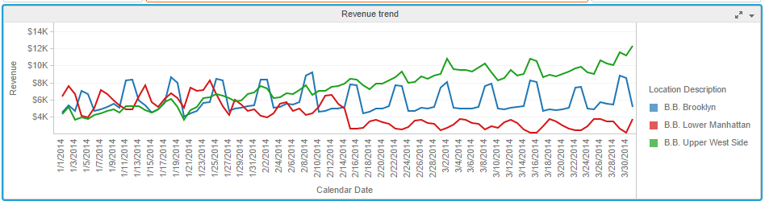

Heat Map visualization depicts to average order counts and revenues for all three locations for specific day of week .It shows that B.B .Upper West side has maximum average count and avg revenue on sat ,sun since order count and item count is maximum

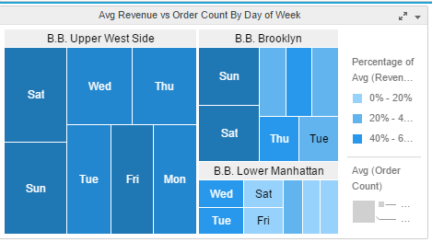

Bubble charts depicts item count and order count for each day of the week.

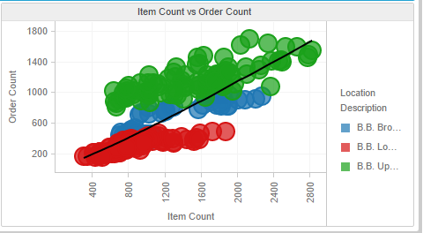

Sheet 1 analyses which of the location is performing worst i.e. B.B.Lower Manhattan and which are improving B.B.Brooklyn.

Sheet 2 analyses the cause for these problem of improving and worsening conditions of restaurant.It compares the location data with NYC Health Inspection data

Map shows you the zip codes of New York colored by the average health inspection score of the restaurants in that area. It shows health inspection scores are very less (green area is less) means health is not good which adversely affects revenue of restaurants

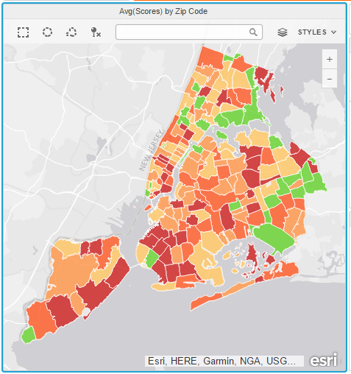

Now bubble chart shows effect of score on revenue. After selecting internal in filter , it shows that B.B .Upper West side has minimum score ,none of the score cross reference lines means all are above grade C, that’s why revenue of that location is maximum. Avg Boro Scores is also 99 i.e. maximum

B.B.Brooklyn has good avg score and score by boro ,so its revenue is not so less it is increasing while B.B.Lower Manhattan scores cross reference line i.e. Grade C (lowest grade) after mid of February so revenue is minimum.

